1. Read the question and the student’s answer carefully.
2. Use the mark scheme to award the student a number of marks and annotate their answer with suggestions to improve.
Stretch: Rewrite the answer to show how it should be done!

Question:
15 g of calcium hydroxide is dissolved to make up 250 cm³ of solution.
- Calculate the concentration of the solution in g/dm³. (3)
- State the chemical formula for calcium hydroxide. (3)
- Calculate the relative formula mass of calcium hydroxide. (2)

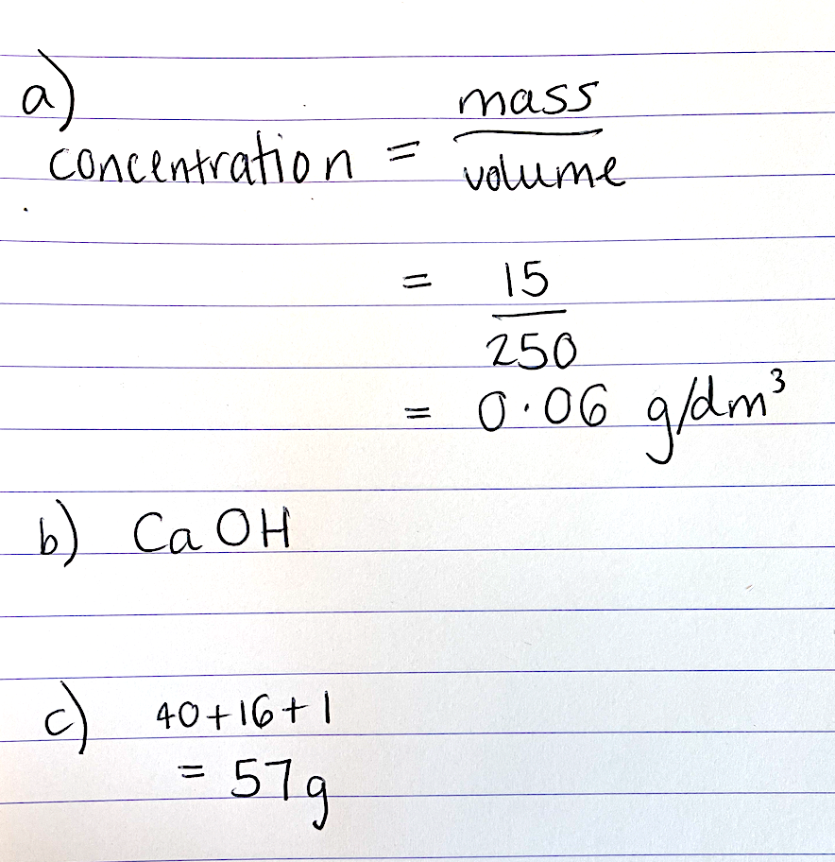
Student answer:

Marks awarded= _______
Mark scheme:

Point | Mark
$$Concentration =\frac{mass}{volume}$$ | 1 (equation)
15/0.25 | 1 (substitution, including conversion to dm³)
60 g/dm³ | 1 (answer)

- Ca(OH)₂

- Allow error carried forward from Qb, calculating the correct Mr from the incorrect chemical formula.
Allow 2 marks for correct answer with no working shown.

Point | Mark
40 + 2(16+1) | 1 (working)
74 | 1 (answer, no units)

